**MSFT:**

RBC Capital Marketslowered its price target for Microsoft to $47 today. And analysts at Morgan Stanley lowered their price target on shares of Microsoft from $50.00 to $46.00 on Wednesday, March 18th.

And technically analysis:

MSFT is below its 50-day and 200-day simple moving averages at $43.02 and $44.58, respectively. The stock is down 11.8% year to date with its 2015 low of $40.23 set on Feb. 2. In addition, the “death cross (the 50-day simple moving average crosses below its 200-day simple moving average), along with the average short order (the MA5, MA10, MA30 is listed from the bottom to the top), both indicate the price will drop.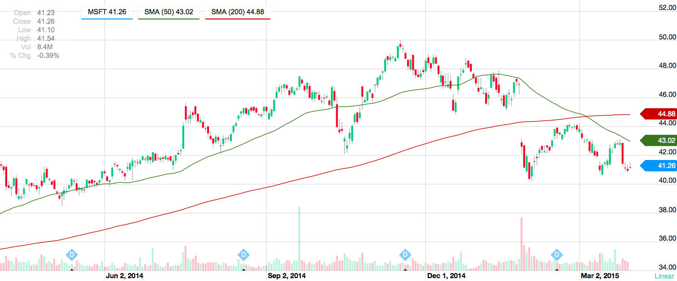

But there is a good news for Microsoft today: KPMG declared an expansion of its planned relationship with Microsoft Corporation, to comprise a global partnership to jointly deliver new suites of innovative solutions and services in data and analytics. The partnership signals an important phase in the Microsoft, which I think may improve the Microsoft’s EPS for the following quarters, may further increase MSFT price.

**Alibaba:**

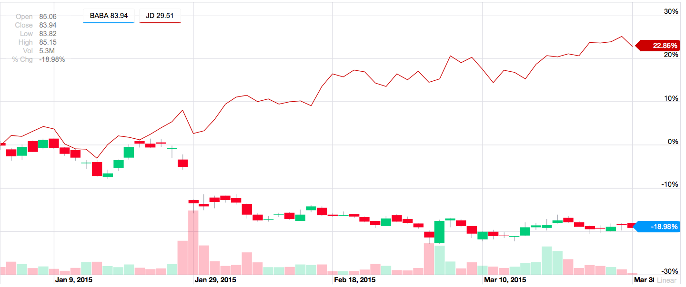

Alibaba may be the undisputed leader of China's e-commerce market. But there are many strong competitors that we should not underestimate, for example, the JD, which has the backing of Chinese social media Tencent. JD also went public last year and has been a far better performer than Alibaba. Shares of JD are 32% above their first day closing price. This year alone, JD is up nearly 20% while Alibaba's stock has fallen 20%.

And I think that the effect that the lockup expiration period for Alibaba stock took will still last for a while. Insiders will be able to sell 429 million shares of Alibaba, and some institutional investors may look to cash in now, after all, the offering price for Alibaba, was $68 a share. In addition, Morgan Stanley recently said that Yahoo offers investors [a 20% discount on Alibaba](http://seekingalpha.com/news/2397236-morgan-stanley-buy-yahoo-to-get-alibaba-at-a-20-percent-discount) shares. So I think it is still not an excellent buying opportunity now.

But there is also a good news for Alibaba: Alibaba has signed a digital music distribution deal in China with BMG. The deal, one of the first in [China](http://www.reuters.com/places/china) made by a major music publisher rather than a label, will bring more than 2.5 million copyrights to Alibaba.

**Airlines stocks:** 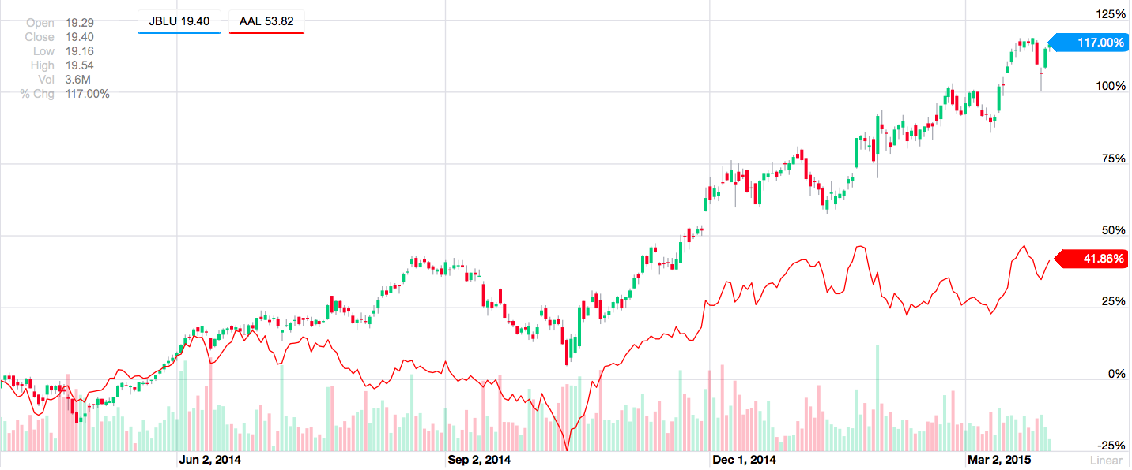

This is the image for the stock prices for the Jet Blue and American Airlines.

*I think that the airline stocks are one of the best investments in today's low-cost fuel environment.*

Airline stocks have increased more than 50% over the past six months as oil prices continue their steady decline. Fuel can be an airline's largest expense. The airline industry has reported operating expense falls over the past few months due to lower fuel prices. Thus the airline stocks are getting a lift following earnings.

In addition, concerns that a deal between Iran and six of the world's largest economies over Iran's nuclear program is imminent have sent oil prices down the last two sessions as an agreement would signal an end to sanctions against the country that would lead to an even larger supply of oil on the market. Iran has until this Tuesday to come to an agreement.

**Kraft Foods: Up 44 percent last week** 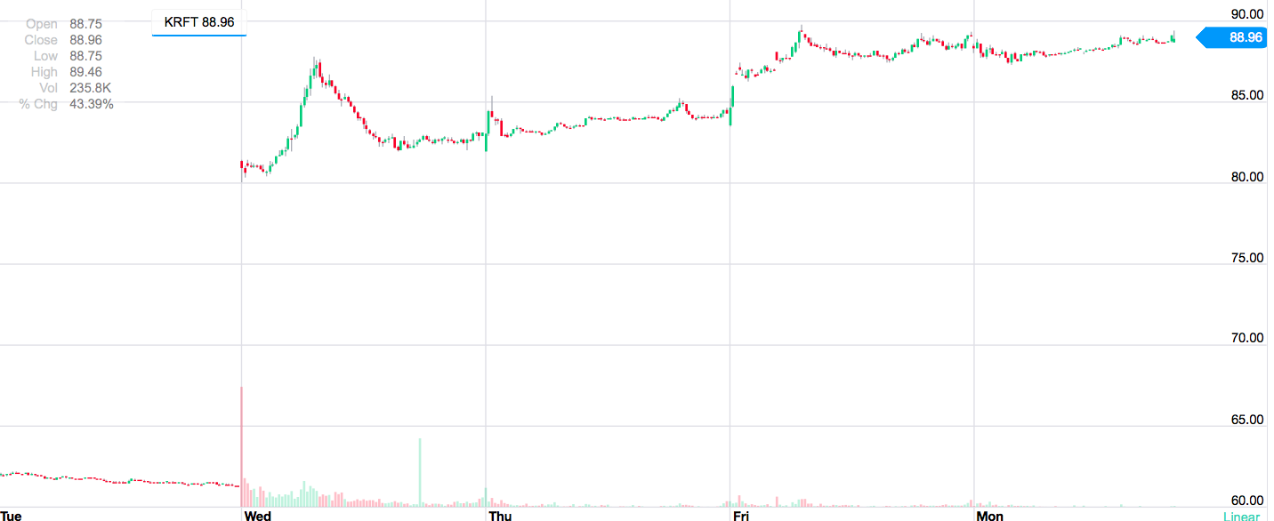

Shares KRFT reached an all-time high of $89.84 on Mar 27, after it announced a definitive merger agreement with privately owned ketchup maker, H.J. Heinz Company, to form The Kraft Heinz Company.

Once combined, the Kraft Heinz Company will be the third largest food and beverage company in North America and the fifth largest in the world. The merger is reportedly valued at $46 billion.

Shares of the food company have risen almost 45% since it announced the Heinz merger deal. The deal is backed by Brazilian private equity firm, 3G Capital, and the billionaire investor, Warren Buffet.